Bike Data Descriptive Analysis

How many of each bike was used in the data?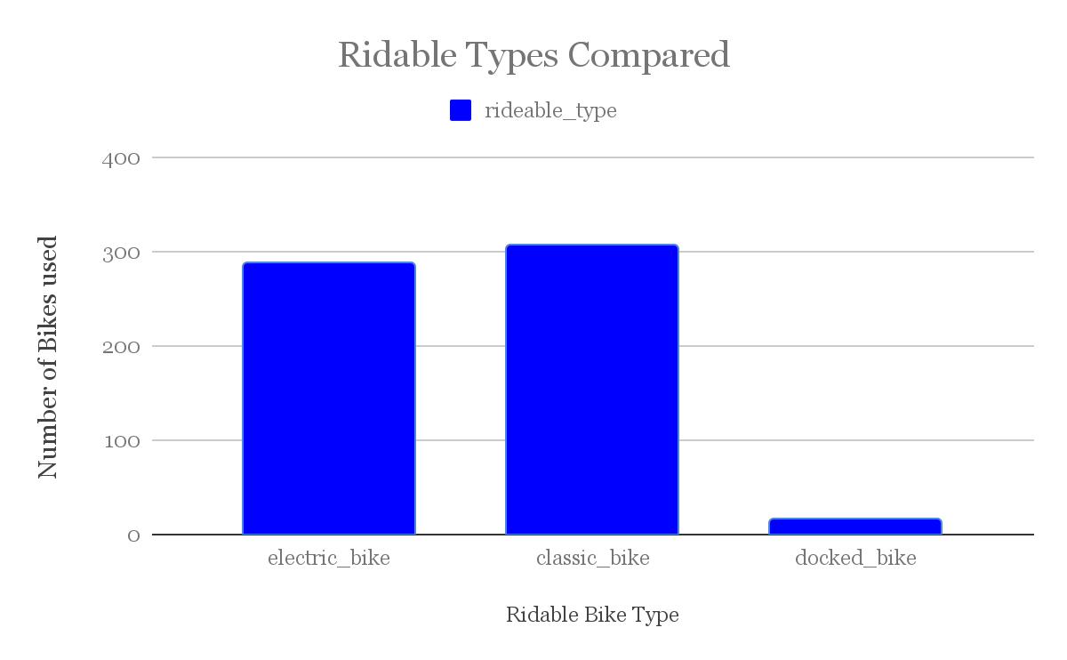

Classic Bike: 306

Electric Bike: 288

Docked Bike: 15

How many riders were Members and how many of them were casual?

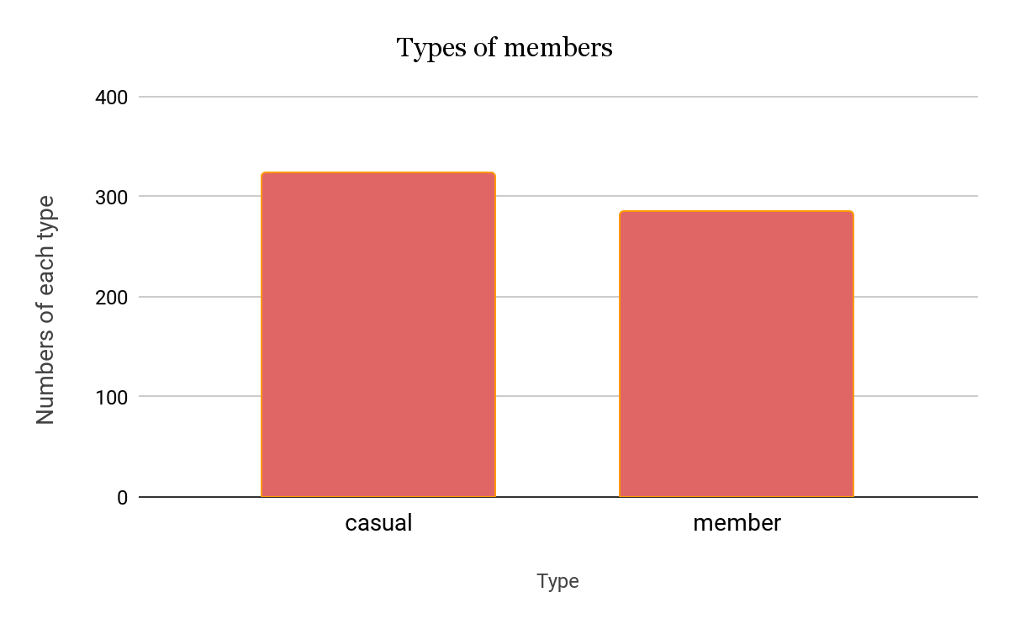

Casual: 324

Member: 285

What is the bike length duration of a casual rider compared to the ride length of members?

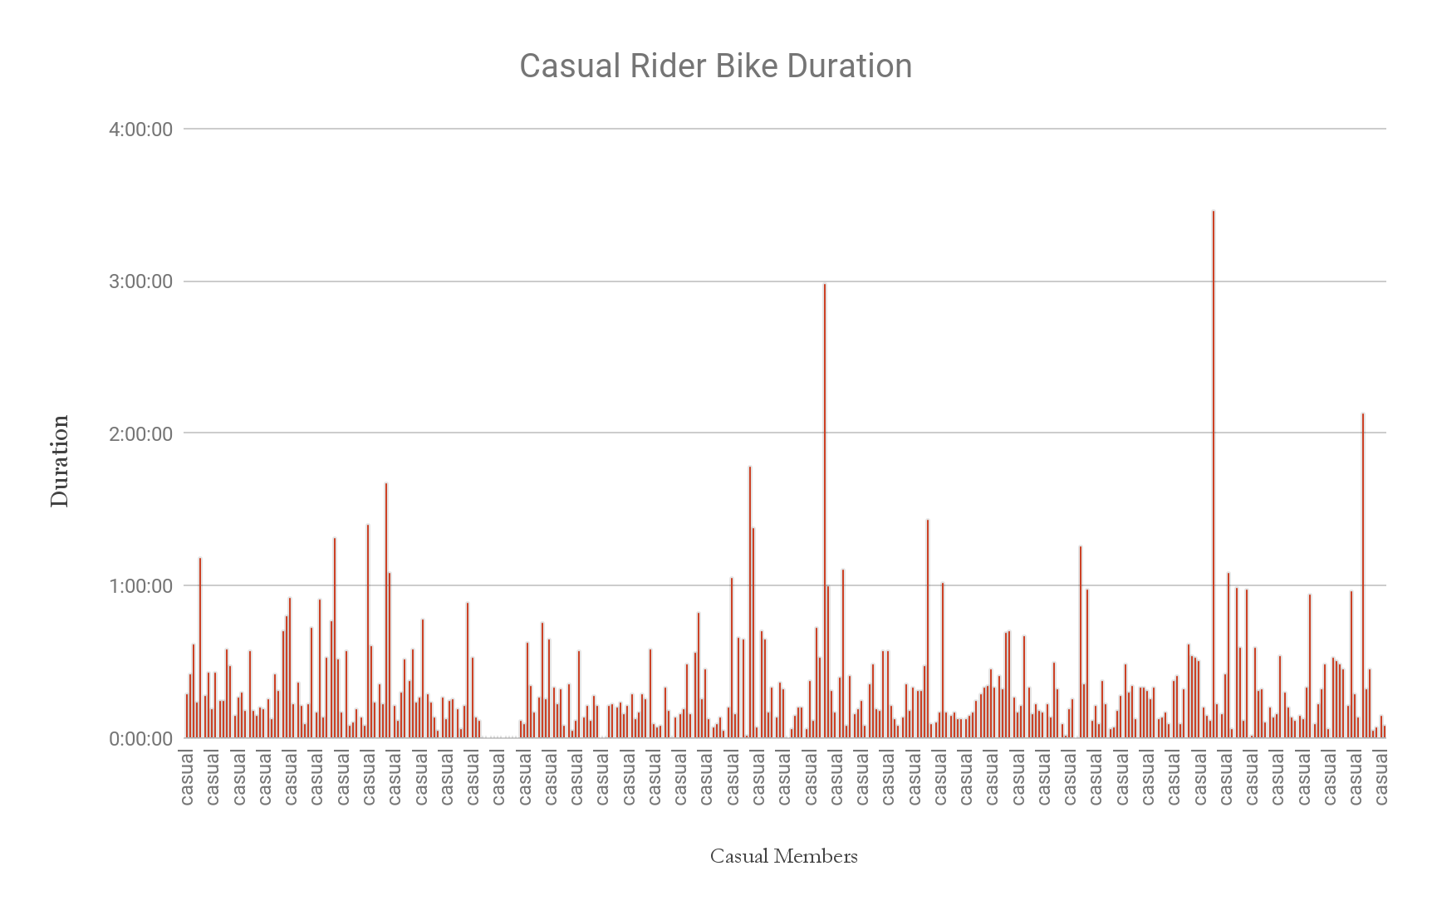

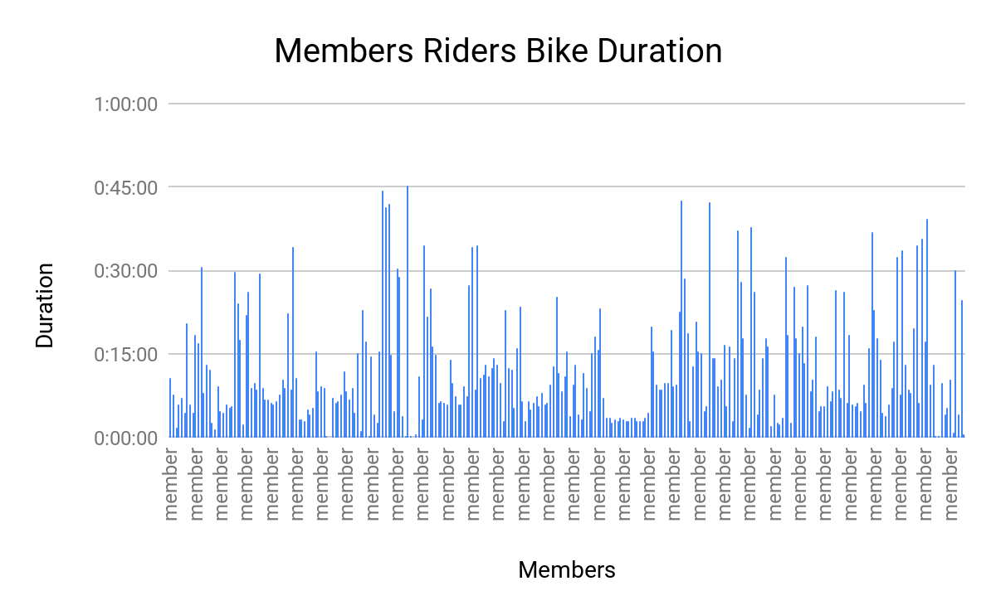

* According to the graph, you can see that causal riders ride for longer periods of time compared to members
* Members usually ride for around 15-45 minutes, with 45 minutes being their max
* On the other hand, casual riders consistently ride for longer than half an hour, and have rode for more than an hour on many occasions
* Casual riders also have the highest duration as one rider rode for over 3 hours.

Calculations

Average Ride Durations: 16:46 Minutes

Ride duration Medien 3:27:20

Mode day of week: 7

Pivot Tables

This pivot table show the number of rides per day on each of the seven days

|  |  |  |  |  |  |  |  |  |
| --- | --- | --- | --- | --- | --- | --- | --- | --- |
|  | *Day of week* |  |  |  |  |  |  |  |
|  | 1 | 2 | 3 | 4 | 5 | 6 | 7 | Grand Total |
| COUNTA of ride_id | 86 | 78 | 49 | 87 | 81 | 79 | 149 | 609 |

This pivot tables show the average duration of casual riders and members on each of the seven days

|  |  |  |  |  |  |  |  |  |
| --- | --- | --- | --- | --- | --- | --- | --- | --- |
| *AVERAGE of Ride Length* | *Day of week* |  |  |  |  |  |  |  |
| *member casual* | 1 | 2 | 3 | 4 | 5 | 6 | 7 | Grand Total |
| casual | 0:24:24 | 0:14:24 | 0:17:30 | 0:16:29 | 0:17:31 | 0:21:46 | 0:25:08 | 0:20:50 |
| member | 0:11:01 | 0:12:36 | 0:09:23 | 0:13:22 | 0:09:45 | 0:11:18 | 0:15:29 | 0:12:09 |
| **Grand Total** | **0:19:06** | **0:13:34** | **0:12:42** | **0:14:41** | **0:13:35** | **0:16:12** | **0:21:42** | **0:16:46** |

This pivot table shows the average ride length of casual riders and members

|  |  |
| --- | --- |
| *member_casual* | AVERAGE of Ride_Length |
| casual | 0:20:50 |
| member | 0:12:09 |
| **Grand Total** | **0:16:46** |